**Detailed Business Specific Requirements:-**

**Theme**: Self Service Analytics

**Applications**: WRIS-Utilities

**Use Cases:-** GeoViewer-**WRIS-SSA-04**

**Other linked Use Case :-** All Applications with spatial data layers.

**Major Use cases:** Surface Water Bodies (WRIS-MIS-01), River Monitoring (WRIS-MIS-02), River Information (WRIS-MIS-03), Ground Water Prospects Study (2011) (WRIS-MIS-04), Forest / Tree Cover (WRIS-MIS-05}, Land Degradation (2015-18) (WRIS-MIS-06), Land Use — Land Cover (WRIS-MIS-07), Soil Type (WRIS-MIS-08), Wasteland Study (WRIS-MIS-09), Rainfall (WRIS-MIS-10), Evapo-transpiration (WRIS-MIS-11), Soil Moisture (WRIS-MIS-12), Inland Navigation Waterways {(WRIS-MIS-13), Socio-Economic Census (WRIS-SSA-02), Wetland Inventory (WM-UC-01), Ramsar Sites (WM-UC-02), Wetland Catchment (WM-UC-03), Hydrometry of wetlands (WM-UC-04), Wetland monitoring (WM-UC-05), Wetland restoration (WM-UC-06), Water quality of wetlands (WM-UC-07), Trends in wetlands (WM-UC-08), Glacial Inventory (GA-UC-01), Glacial monitoring (GA-UC-03), Glacial mass balance study (GA-UC05), Snow gauging (GA-UC-06), Watershed snow cover area (GA-UC-04), Snow melt analysis (GA-UC-07), Glacial Hydrometry (GA-UC-08), Snowmelt Runoff to the River (GA-UC-10), Glacial Lakes Inventory (GA-UC-02), Change in size of glacial lakes (Near Real time) (GA-UC11), Glacial Lake Storage Status (GA-UC-12), Glacial Lake Cross Section Generation (GA-UC13), Glacial Lake Vulnerability assessment (GA-UC-14), Glacial lake outburst (GA-UC-09), District At A Glance (WRIS-MIS-16)

**Description**:- Geoviewer enables geographic visualization that deals solely with displaying information that has a geospatial component to it. It is a common window to most of the spatial layers to be seen altogether so as to get a whole picture of the data collected. it also provides rich set of tools and techniques supporting geo-spatial data analysis through enhanced visualization.

**Used By (End Users):-** Researcher, Planners, Decision makers, administrators, academicians and public.

**Priority**:- **High Priority**

**Phase:-** **Phase 1** Subsumed

**Governance Need (Business Problem):-**

**Issue**:- Geoviewer requires spatial layers from other modules to be hosted on this module.

**Approach**:- Geoviewer from India WRIS will be subsumed with additions for new as well as updated geospatial layers of WARIMS modules.

**Output:-**

**Expected Outcome:-** Geoviewer: This module is an attempt to bring all the different sets of data on a single application for a comparative and interlinked view to derive a holistic picture with overlay. For assisting the same, many GIS based tools are provided for exploration of datasets. The user will be enabled with functionality to turn the visibility on/off for the different layers in the dataset to create user defined view.

**Visualization:-** Geoviewer GUI can also be seen in the adjoining figure where various data layers can be overlaid as per users’ choice. (Example: Geoviewer, India WRIS)

**Frequency of Up-dation:-** Regular updations when any data layer from new module is added or any hosted geospatial layer is updated.

**Measure of Success:-** Hosted Data Layers are working and Web App is successfully running on the portal.

**Input Data Required:- Data Points:**

|  |  |
| --- | --- |
| **Data Point** | **Data Source** |
| Administrative Boundary Layers | NWIC |
| Hydrological Boundary Layers | NWIC |
| Socioeconomic Layers | Census of India |
| Wetland Layers | NRSC |
| Glacial Lakes | CWC |
| Ground Water Prospects Study | NRSC |
| Surface Water Bodies | NWIC |
| Land Degradation | NRSC |
| Forest/Tree Cover | NRSC/FSI |
| Land Use Land Cover | NRSC/NWIC |
| Soil | NBSS & LUP |
| Coastline | RMSI |
| Water logging/Soil Salinity | CWC |
| Water Resource Projects | CWC |
| Inland Navigation Waterways | IWAI |
| Flood Inundation | NRSC |
| Reservoir Survey | CWC |
| Agro climatic/Agro ecological Layers | NITI Ayog/ICAR |
| Infrastructure | Airport Authority of India, NHAI, NRDB, Indian Railways |
| Reported Extreme Temperature, Rainfall & Earthquake Events | IMD |

Abbreviations:

**CGWB:** Central Ground Water Board

**CWC:** Central Water Commission

**FSI:** Forest Survey of India

**IMD:** Indian Meteorological Organization

**IWAI:** Inland Waterways Authority of India

**NBSS&LUP:** National Bureau of Soil Survey & Land Use Planning

**NHAI:** National Highway Authority of India

**NRDB:** National Road Database

**NWIC:** National Water Informatics Centre

**NRSC:** National Remote Sensing Centre

**Process:**

**Algorithm/Tools:-** Flowchart for various processes involved in creating Geoviewer are as follows:

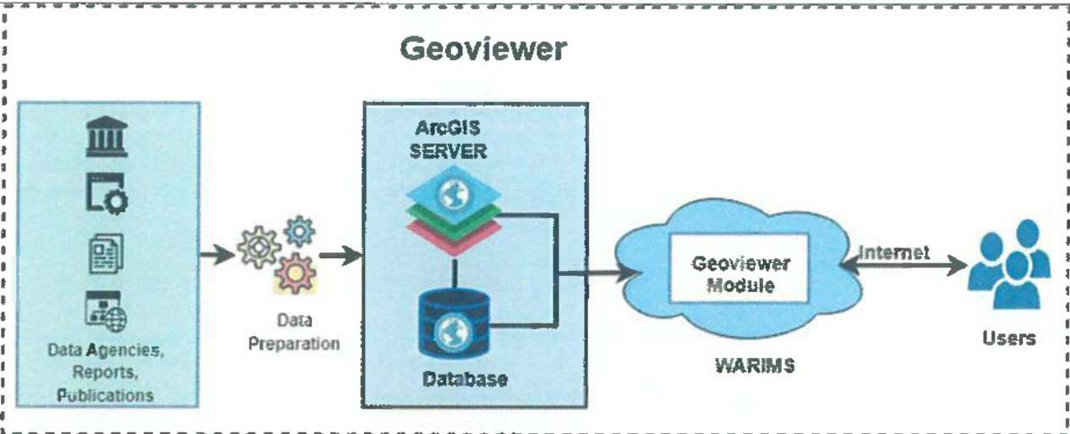

Geospatial layers are generated from data received from data agencies in form of tables, pdfs, reports, shape files, geodatabases, etc. These layers are shared using ESRI QGIS server through Web app which will be hosted in the module. GIS based tools such as egend, Layer list, Base map, Print, Surface profile, Share, Add Data, Zoom in/Zoom Out, Previous/Next Zoom, Locate, Global Search, Attribute table, Select, Swipe, Measurement, Bookmark etc. will be provided. This will enable user for querying through data for desired results.

**Different data layers to be shared on Geoviewer include the following list:**

* Administrative Boundary Layers
* Hydrological Boundary Layers
* Socioeconomic Layers
* Wetland Layers
* Glacial Lakes
* Ground Water Prospects Study
* Surface Water Bodies
* Land Degradation
* Forest/Tree Cover
* Land Use Land Cover
* Soil
* Coastline
* Water logging/Soil Salinity
* Water Resource Projects
* Inland Navigation Waterways
* Flood Inundation
* Reservoir Survey
* Agro climatic/Agro ecological Layers
* Infrastructure
* Reported Extreme Temperature, Rainfall & Earthquake Events

These GIS data layers will be published in QGIS Enterprise. A web-app named Geoviewer using published layers with GIS functionalities/tools for users will then be published in QGIS Enterprise. This app will then be hosted on the geoportal. Some of the GIS tools are shown.

Various Data layer list hosted on Geoviewer

Swiping various data layers on map panel in GeoViewer

Adding More layers on map panel in GeoViewer

**Bookmarks:** Regions at predefined Zoomed scales in Geoviewer (Can be created by users as per their requirements). Telangana & Uttar Pradesh bookmarks created by user below.

**Select Feature:** Upon drawing a rectangular selection in the Map panel, all selectable layers will be shown on a right-side window and attributes of selected features of different layers can be seen in the attribute table below.

**Data Validation:-** Geospatial layers need to be checked for working properly before hosting on Geoviewer.

**Software Technologies:-**  QGIS Enterprise

**Dependencies & Risks:** Ability to host data layers, QGIS Server

**User Acceptance Testing (UAT):-** NWIC

**Development Responsibility:** NWIC

**References :-**

https://indiawris.gov.infwris/#/Geoviewer

https.//indiawris.gov.in/downloads/Functional Requirement Specification1.pdf

https://indiawris.gov.in/downloads/Data Assessment Reports.pdf

**---End of Document---**